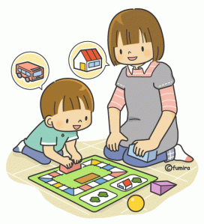

Understanding your Child’s Behaviour

Parent/Carer Course

Parent/Carer,
The Emotional Wellbeing Team are offering a parent course via Microsoft Teams on ‘Understanding your Child’s Behaviour’.
The aim of the course is to provide parents with strategies and guidance they can use at home to support their child’s behaviour. The sessions are also an opportunity to reflect with one another and the facilitators on how best to apply the evidence-based strategies highlighted in the course to help with your child’s behaviour.
We believe that parents are the experts when it comes to their child. You have a better understanding of how your own child might respond and what will encourage and motivate them to try different things. Parents are in the best position to support their child in between sessions and well beyond the treatment.
The programme is designed:
- To promote positive relationships, attachment and pro-social behaviour through sensitive responding
- To provide appropriate routines, boundaries and limit setting
One of the key aims is to improve your confidence in your ability to support your child’s behaviour. We highlight positive skills and responses of the parent in order to build your confidence and empower you to support your child.

If you are interested in this course, please complete a request form that is held by your Senior Mental Health Lead at your school. Please complete this by Monday 12th May 2025

Course dates

Session Number | Date | Time | Location | Course Content
1 | Monday 2nd June | 09.30 – 11.00am | Microsoft Teams | Understanding the current difficulties and Course aims
2 | Monday 9th June | 09.30 – 11.00am | Microsoft Teams | Goals and Attending
3 | Monday 16th June | 09.30 – 11.00am | Microsoft Teams | Praise and Rewards
4 | Monday 23rd June | 09.30 – 11.00am | Microsoft Teams | Selective Ignoring & Effective Instructions
5 | Monday 30thJune | 09.30 – 11.00am | Microsoft Teams | Consequences, Time-out and Family rules
6 | Monday 7th July | 09.30 – 11.00am | Microsoft Teams | Ending and Trouble-shooting

