Briefing for Schools

Kent County Council (KCC) is running a public consultation on proposed changes to support for children and young people with mild to medium emotional wellbeing and mental health needs.
The consultation is from Wednesday 25 September to Tuesday 12 November 2024.

What is the consultation about?
KCC currently commissions the Kent Children and Young People’s Counselling Service for children and young people aged 4 to 19, living in Kent with mild to medium emotional wellbeing and mental health needs. This is delivered on KCC’s behalf by the Kent Community Health NHS Foundation Trust as part of the School Health Service.
The proposal is to commission a new Therapeutic Support Service instead of the Counselling Service when the current contract ends in March 2026.

What would the new service look like?
The new service would still help children and young people aged 4 to 19 years who need mild to medium support for emotional wellbeing, and the budget would remain the same. However, the way that support is delivered would be different, to help meet the needs of more children and young people, more quickly.
The new service would offer a range of creative and therapeutic activities to help children and young people learn new skills and techniques to express how they are feeling, understand their emotions and build resilience. These activities would be mainly delivered as themed, age- appropriate group sessions. They could include:
- Theatre, drama, culture, music, singing or journalling
- Sport and team building activities
- Play therapy for younger children
- Talking therapies such as Cognitive Behavioural Therapy (CBT) or Dialectical Behaviour Therapy (DBT.
We know that some children and young people might find it difficult to join a group and we would still have some one-to-one support available.

What would the benefits be for children and young people?
- More children and young people could be supported.
- They would be able to get support more quickly. This would reduce the risk of difficulties getting worse.
- They would have greater choice in the support available.
- They would have more opportunities to meet others who are going through similar experiences and to support each other.
- They could receive support that is tailored to specific needs, for example, neurodivergent children and young people.
The service would be delivered as part of the Kent Family Hub network and work closely with specialist children and young people’s mental health services (which are commissioned by NHS Kent and Medway and are not part of this consultation).

What happens next?
Our proposals are subject to feedback from the consultation and no decisions have been made. We would be grateful if schools could please support the process by:
- Making children, young people, parents/carers, families and staff aware of the consultation and sharing our consultation weblink: www.kent.gov.uk/cypwellbeingsupport
- Encouraging them to complete the online questionnaire www.kent.gov.uk/cypwellbeingsupport or Word version (available on the webpage or in hard copy on request - details below).
- Encouraging young people to view the Young People’s Summary version of the consultation document and questionnaire at www.kent.gov.uk/cypwellbeingsupport. An Easy Read version is also available from the webpage or on request.
To support schools in promoting the consultation, we are also sharing:
- Social media graphics – See Appendix 1
- Electronic versions of promotional poster and postcard – See Appendix 2

Alternative formats and paper copies:
If anyone needs any help taking part in the consultation, has a question or needs paper copies of the consultation material, they can:
- Email phstprogramme@kent.gov.uk
- Telephone: 03000 413 487
For any alternative formats or languages, they can email alternativeformats@kent.gov.uk or call 03000 421553 (text relay service number 18001 03000 421553).
These phone numbers go to answer machines and are monitored during office hours.
Completed paper questionnaires can be returned to a local Family Hub for onward posting to KCC Public Health Business Support at the address below:
Public Health – CYP Emotional Wellbeing Consultation
Kent County Council
Invicta House
Maidstone
Kent ME14 1XX
The deadline for responses is midnight on Tuesday 12 November 2024.

Appendix 1 - Social media graphics

- Instagram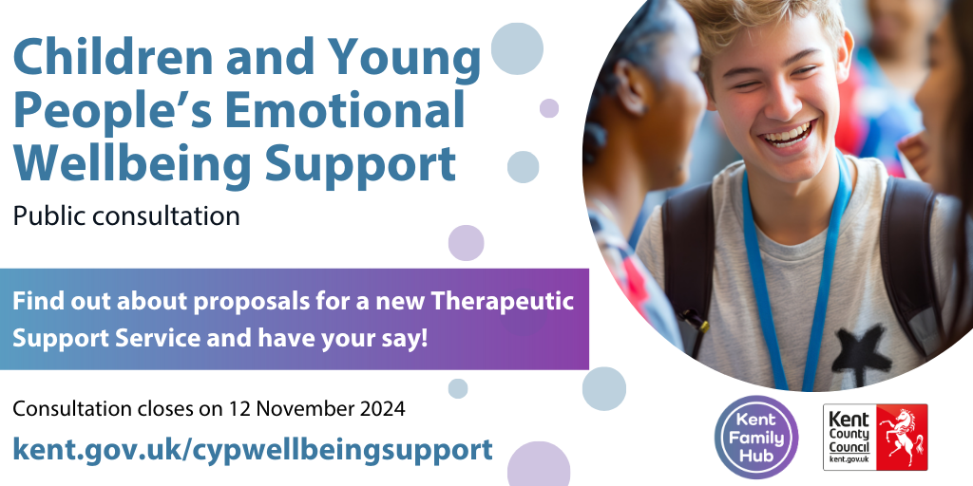

- Facebook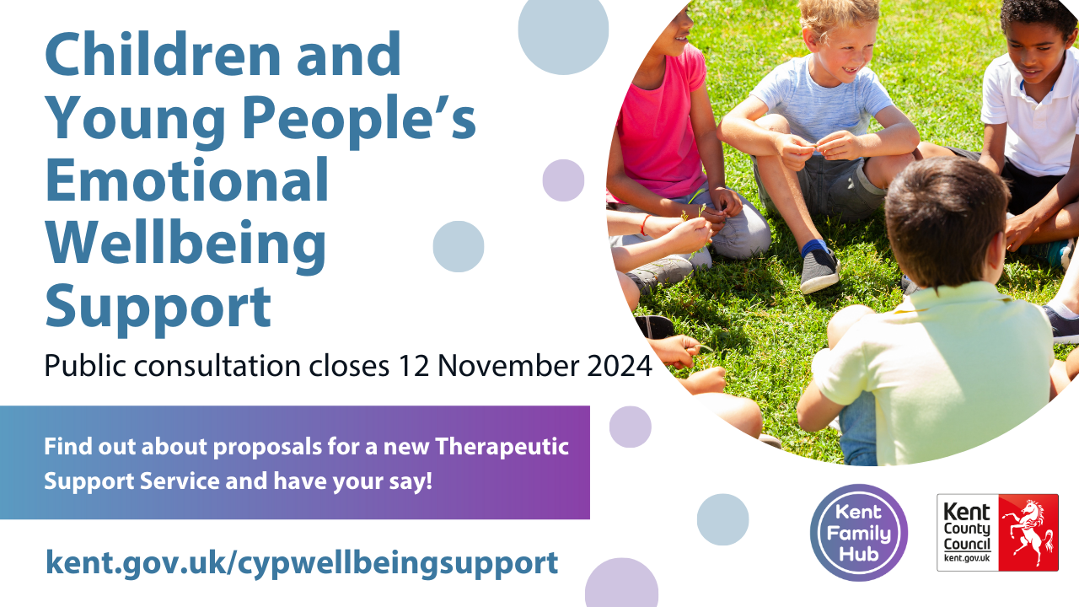

- Nextdoor

- X (Twitter)
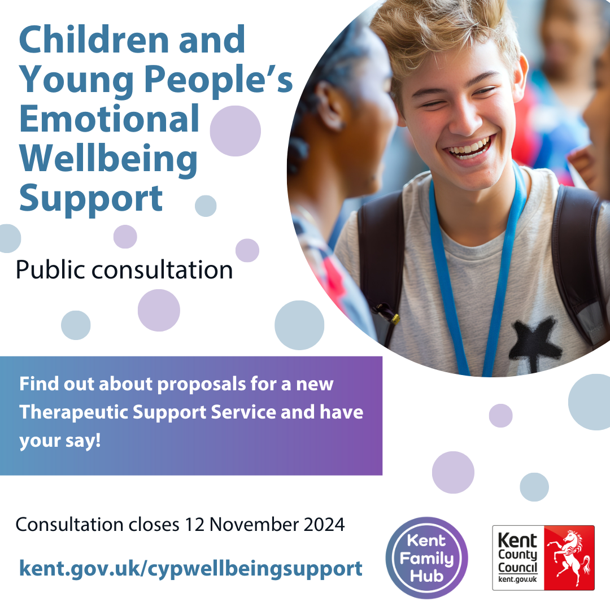

Appendix 2 - Electronic versions of promotional poster and postcard

